Packing List:

(1) Complete airframe including wing, fuselage, and stabilizer

(1) Wire Harness with green 6pin MPX connector and loose RC connectors

(1) 24” servo extension for elevator

(1) Battery harness Deans x (2) male RC

(1) Servo cover sheet (small for ailerons, large for flaps)

(2) Flap control horns (smaller pair)

(2) Aileron control horns (larger pair)

(1) Elevator control horn (smallest individual horn)

(4) 4-40 Sullivan threaded clevises (for flaps and aileron pushrods)

(1) 2-56 threaded clevis for elevator pushrod

(1) 2mm ball stud and plastic ball link for elevator pushrod

(1) 5mm x 91mm carbon tube for elevator pushrod

(1) 2-56 threaded rod for elevator pushrod

(1) 4-40 threaded rod (cut into (4) small pieces for ailerons and flaps)

(1) 5mm wing screw

(2) 4mm tail screws

(1) 3mm allen wrench (for wing screw)

(1) 2.5mm allen wrench (for tail screws)

(1set) Clear wing servo covers (trace in position and cut with scissors)

(1) Clear elevator servo cover

(1) G10 gear tray

(1) 4mm Phillips screw for gear tray mounting

(1) 4mm weld nut for gear tray mounting

Installation Guidelines:

Before proceeding, make certain that you know how to get maximum servo travel from your transmitter… Also, make the decision of what voltage you would like to use. For MKS servos, use only a 4cell Nimh or higher voltage pack with a regulator set to maximum 5.9v. Other high voltage options include 5cell nimh or 2s Life or Lipo in conjunction with high voltage servos such as Hitec 7115TH or JR DS398HV.

Wing

The first step (if not already done) is to make a hole for the wire harness to exit the wing. The ~10mm diameter hole should be made on the centerline and 50mm ahead of the rear wing screw. 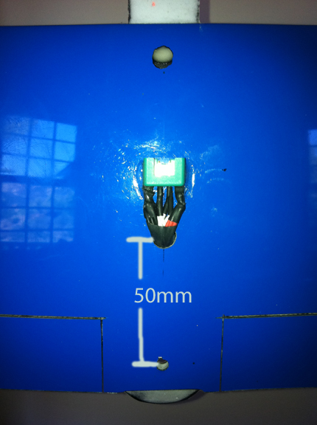
The harness is supplied with the plastic servo connectors shipped loose. This allows you to thread the harness through the small hole more easily. Be very careful when assembling the plastic pieces to ensure each wire goes in the correct position. It is helpful to look at the supplied elevator extension wire to confirm orientation is correct. Note that the female plastic piece has a tab inside and beveled corners that indicate the correct orientation. My preference is to cut the servo connectors off and solder the servos to the harness. If you elect to use the servo connectors instead, use a piece of heat shrink over the assembled connectors to help prevent accidental disconnection.

Servo Choices

The flaps and ailerons are bottom hinged and are intended to be top driven. The recommended flap, aileron, and elevator servo is the MKS DS6125 installed with Smartmodel aluminum frames with external bearings on flaps and ailerons. The Hitec HS7115th also fits very easily but has a little more bearing flex and may be more susceptible to gear damage due to the plastic case and smaller gearset. I would recommend these for K2m limited to 325mph or less. JR DS398/DS398HV can be made to work with some sanding of the case and making a relief cut in the servo cover. The wing's drag spar is interrupted at the servo locations to facilitate installation of the servo frames. It is not necessary but if you want ultimate strength, you can fill this gap after installation (I haven’t found it necessary) using a piece of epoxy soaked sponge.

Ailerons
I prefer using a metal arm regardless of which servo is chosen. The arm should be made to be very short so that all of the servo throw can be used. On the MKS aluminum arms, I drill a 1/16” hole 5-6mm out from the centerline to accept the 4-40 clevis. This will allow 5-6mm of up travel (measured at the aileron tips) Remove the excess arm length to ensure it will fit under the servo cover. I also, use a file or dremel tool to remove some material on the inner hub of the servo arm as well as (1) side of the clevis to allow full forward travel without binding (see photo). 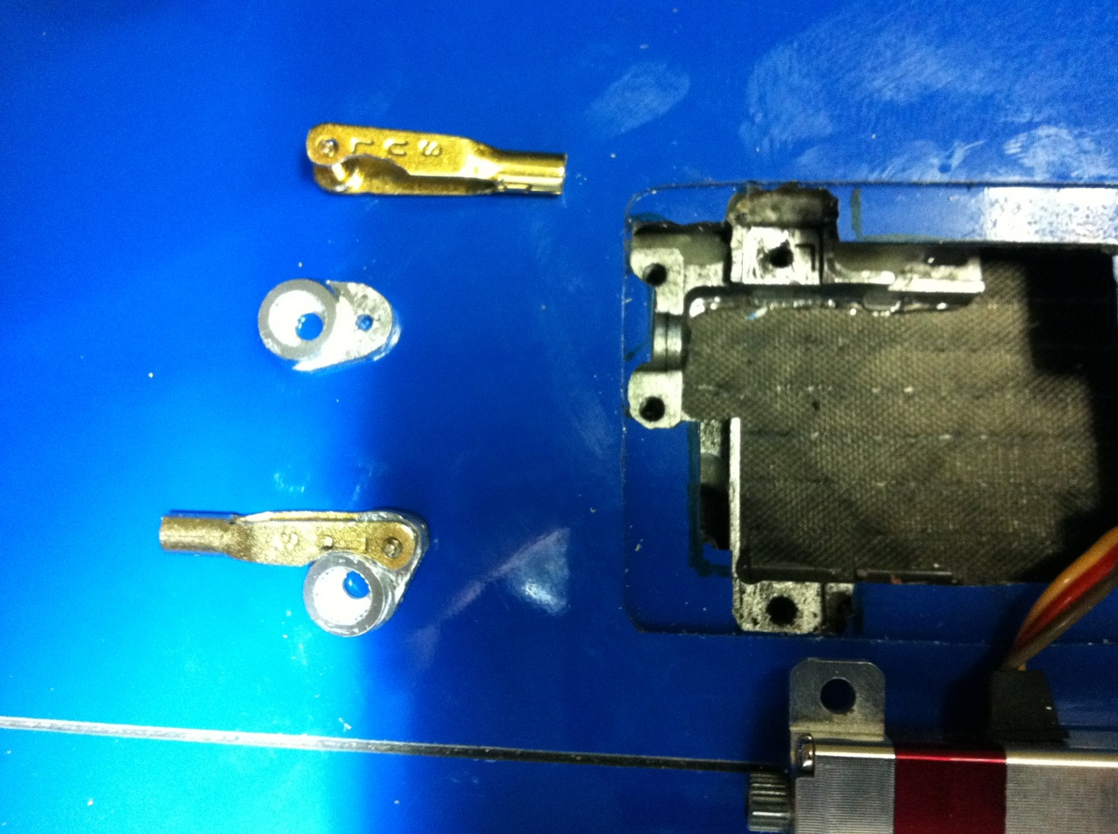

If using the MKS with frames, you will have to apply the epoxy to the wing skin, then insert the frame first, and then mount the servo as the servo and frame won’t fit into the cutout if bolted together. Before glueing, use a dremel to remove some of the frame base where the pushrod will interfere at full up aileron (this can be done later once installed but it is easier now). 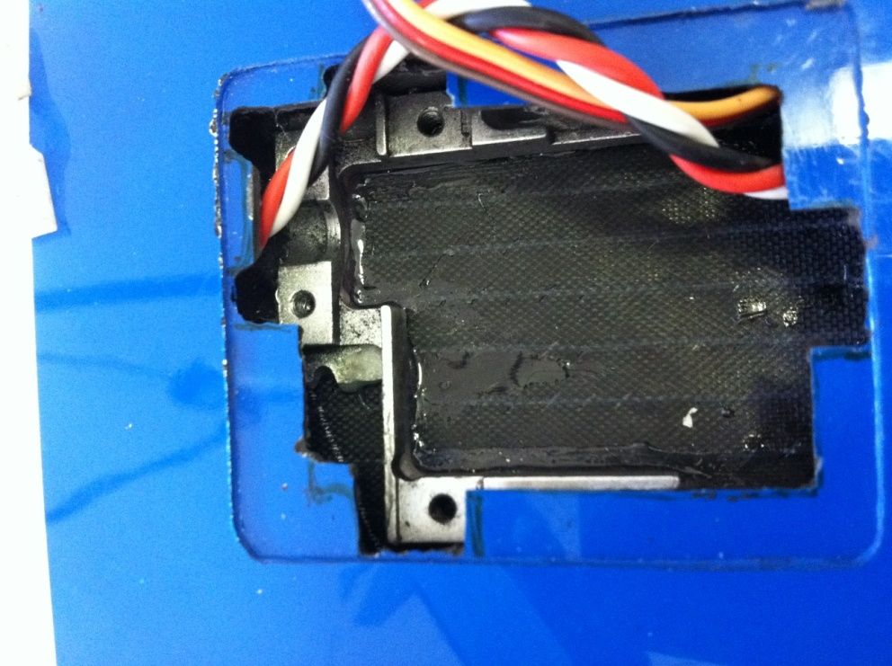

Once the servo is mounted, open the aileron enough to visually align the location for the control horn with the servo arm. Once the slot for the control horn is marked, I typically use a small end mill on a Dremel tool to grind all the way through the top skin, carbon hose stiffener, and wiper. Be careful not to go through the lower skin (there is no balsa core material there).

The control surface horn (larger of the two pairs are for ailerons) should slide into the aileron from the front so that the front edge is just behind the hingeline at the base. Score a line along the horn where the skin intersects and then scuff the horn just past this line to prepare for a good bond. Assemble (2) 4-40 clevis on a short piece of 4-40 threaded rod. If using frames, you may have to shorten the clevises by removing 1/16” of the threads on a belt sander or with a dremel cutoff wheel. The servo arm should be angled roughly 25-30 degrees aft so that it is perpendicular to the pushrod at the neutral position. Thread the pushrod assembly through the wing and attach to the servo arm first. Rotate the servo with the tx and make sure you can achieve full throw without binding. If using the aluminum frames, you may have to remove a small amount of the white plastic bearing retainer to allow clearance for
the clevis.
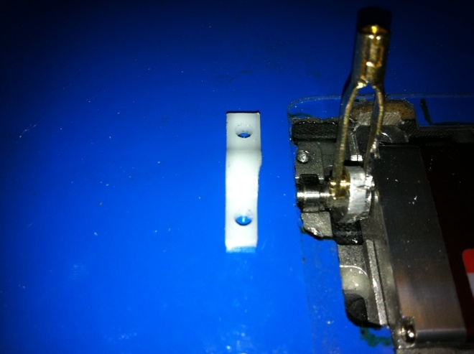

Remove enough material from the upper wing skin ahead of the gap for the pushrod and horn to clear at full up deflection. Now, attach the horn to the pushrod and insert into the aileron cut out. 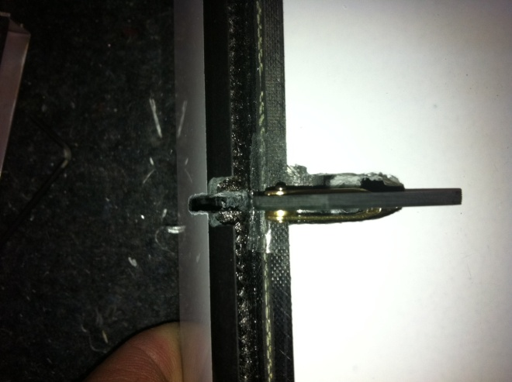

Holding the horn in place, you can confirm maximum control surface deflections up and down. If all is good, epoxy the horn in place. You may want to temporarily put a piece of tape over the hinge to keep epoxy from getting into it during this process.

Add thin CA to all threads and any clevis pins that have any play. Add a dot of thick CA to the clevis pins to prevent them from flexing under loads.

Flaps

Installation of the flap servos and horns is very similar to the aileron set-up with the exception that the servo arm should be angled as far forward as possible (roughly 40 degrees from vertical) in the neutral position. This allows nearly locked out geometry will still achieving sufficient throw. I recommend using the full length MKS aluminum arms to achieve full 80-90 degree flaps. The distance from the servo output shaft centerline to the clevis pin is ~9mm. They will just fit under the larger blistered servo covers.
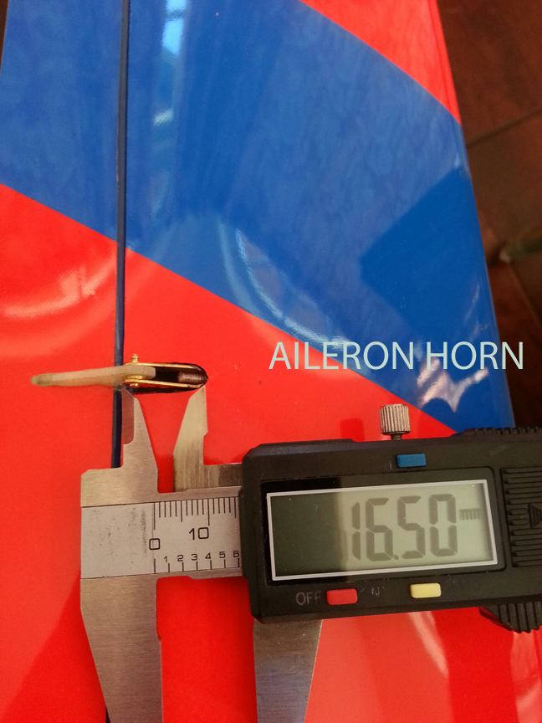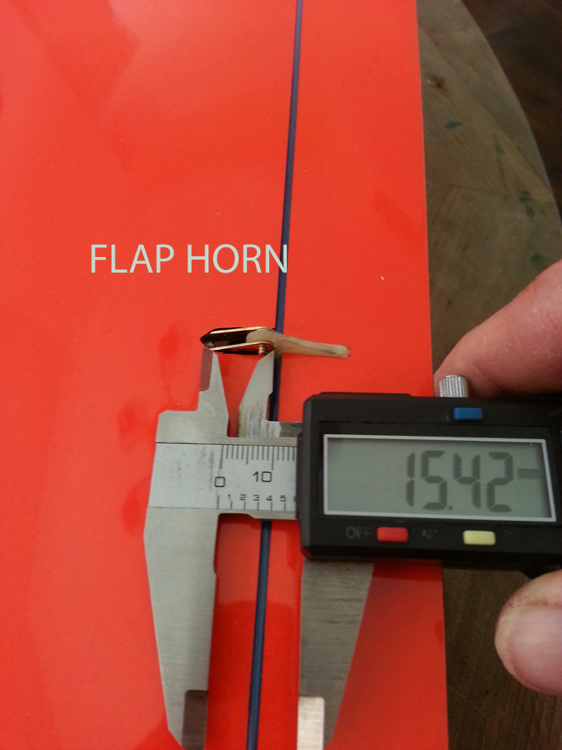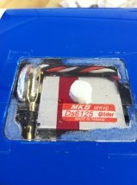
The wing servo covers are supplied un-cut so that they can be custom fit you your final servo and pushrod installation. Once everything is completed, place the cover over the recess such that the clevis is centered and aligned with the blister (larger for flaps and smaller for ailerons). Make a small mark on the cover over each corner of the servo cover recess. Then cut with scissors between each mark. Check for clearance throughout the servo range of motion and adjust as necessary. Place a dot of 5min epoxy in the middle of the servo and at each corner of the cover and then tape in place using clear scotch tape. This makes the cover very rigid and the epoxy will easily release from the cover if you need to access the servo. The clear cover allows a visual inspection before every flight to look for any potential damage from the previous landing or hangar rash.

Fuselage / Elevator

First, mark the centerline on the bottom of the elevator surface. Now cut a slot in the bottom elevator skin with a dremel tool and insert the control horn. Take care not to penetrate the upper skin as there is no balsa core. Scribe a line on the horn to check that the horn is fully seated. It takes some attention to ensure that all of the carbon stiffener is removed allowing the horn to seat fully into the elevator. Before glueing the horn into place, confirm that there is sufficient clearance where the 2-56 clevis will exit the vertical stabilizer. If necessary, you can partially file down the protruding clevis pin. Glue in the horn using the same precautions not to get epoxy into the hinge. The final location of the clevis hole in the elevator control horn should be roughly 8mm behind the intersection of the elevator skin and the wiper and 5mm off of the skin.
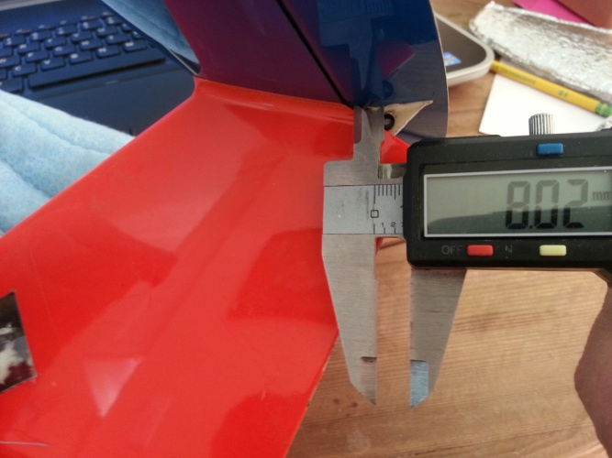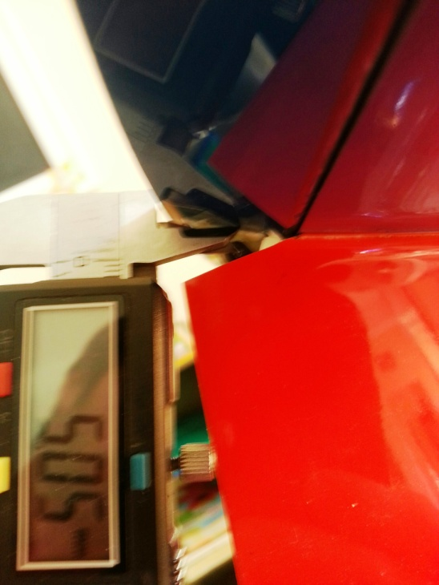

Next, thread the plastic ball link to one end of the 2-56 threaded rod and slide the carbon tube over the rod and up to the ball link. Lay the pushrod on the outside of the vertical stabilizer to determine the desired length. Position the plastic ball link approximately in the center of the servo cutout. Use alcohol to clean the 2-56 rod and try to roughen the inside of the carbon tube using a small round file or the 2-56 rod itself. Now mix some 5min epoxy and thoroughly coat the portion of the threads that will be covered by the carbon tube. Insert into the tube using a twisting motion. Remove excess epoxy and allow to cure.
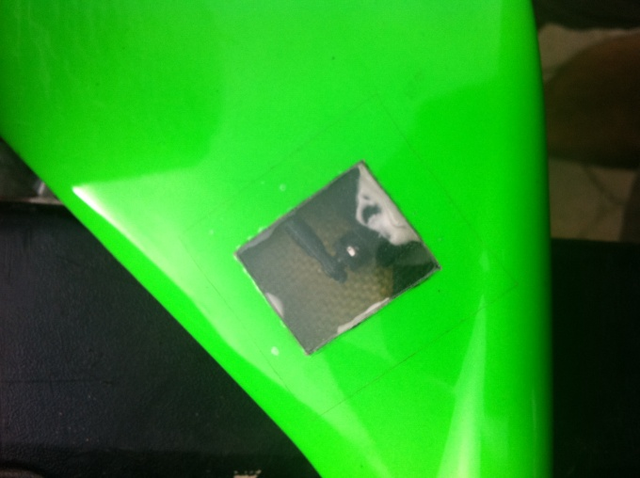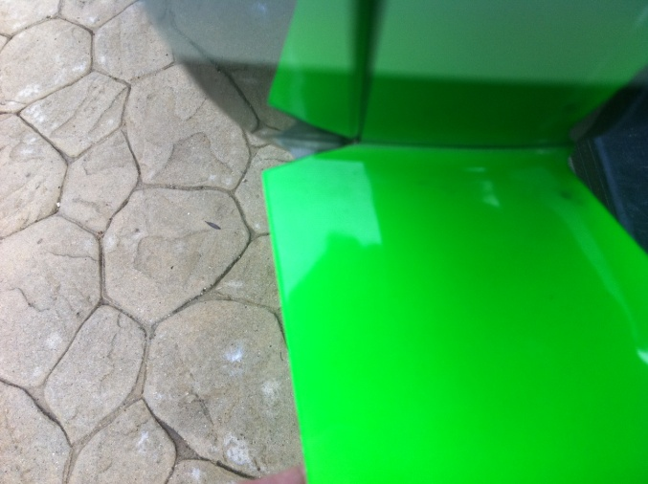
Attach the 24” servo extension to the servo either by soldering (preferred) or the connectors with heat shrink tube as before. I recommend using an aluminum arm for the elevator regardless of servo choice. Aluminum bearing frames are not needed on the elevator and in fact can’t be used because of the ball link connection. The ideal arm length is a short 4mm to achieve the necessary control surface deflection. This also allows the ball link to clear under the servo cover without interference. For the MKS arms, this will mean drilling a 1/16” hole partially into the hub of the arm. Tap for 2mm. I prefer to ‘under tap’ leaving tight threads than to ‘over tap’ leaving loose threads. After threading the ball partially onto the arm, add thin CA and tighten the rest of the way. Add more CA to the exposed portion of the threads and spray with kicker.

Before installing the servo, inspect the area where the pushrod will travel for any excess epoxy that may interfere. Remove with a file if necessary. Check the area where the clevis will exit the vertical stabilizer for necessary clearance. Also remove any excess epoxy where the lower aft corner of the servo will be. Position the servo in the cutout so that the ball link can easily be attached and detached. Now attach the pushrod to both the servo and the control horn. With the servo centered, the surface should be deflected slightly down by approximately one trailing edge thickness (0.5mm). This is the normal trimmed position for the elevator surface.

Before glueing the servo in place, you can hold the servo firmly to get a rough check of control surface throws. When glueing, be sure to get sufficient epoxy under and behind the servo. Maintain correct control surface position and servo alignment while the epoxy cures enough to hold in place. Later, add epoxy on top of the servo to bridge to the upper skin and also to support the middle of the servo cover.

The nose of the fuselage is 2.4Ghz friendly (free of any carbon) from about 1” ahead of the wing leading edge forward. Depending on your RC equipment, there are numerous ways of installing the gear into the nose. The fuselage is supplied in it’s strongest possible configuration. In this configuration, you will be limited to using slender batteries. A 2/3A Elite ‘stick’ or end-to-end type battery pack is practical to fit the small opening and can be made in 4 or 5 cell configurations depending on your needs. If you prefer a larger battery, you can remove some material on either side of the opening without losing too much strength. 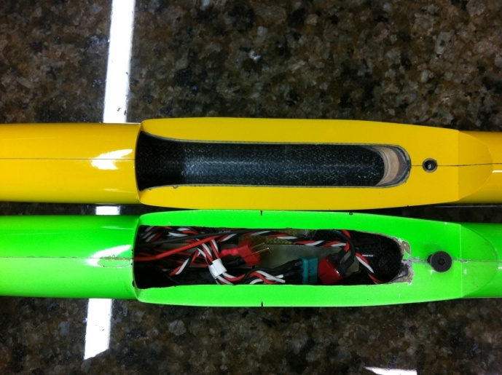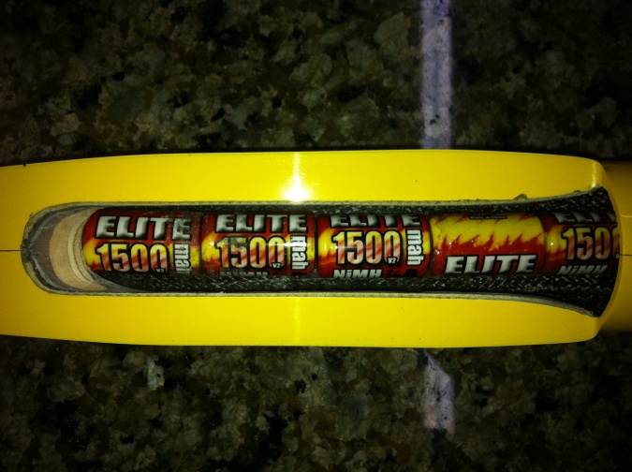

If you anticipate needing to significantly change the amount of noseweight (ie, to accommodate using removable ballast in the wing D-box), it is beneficial to use the supplied G10 gear stick with a removable piece of noseweight (roughly 6.5oz for entire D-box to be filled with lead shot). Alternatively, it is possible to simply pack the battery and rx into the nose and fix in position with either goop or foam pads. Total nose weight without tip or d-box ballast will likely be around 12-13oz to achieve the 58.5mm CG. I recommend using a combination of solid lead pieces with lead shot and epoxy to achieve the greatest density.
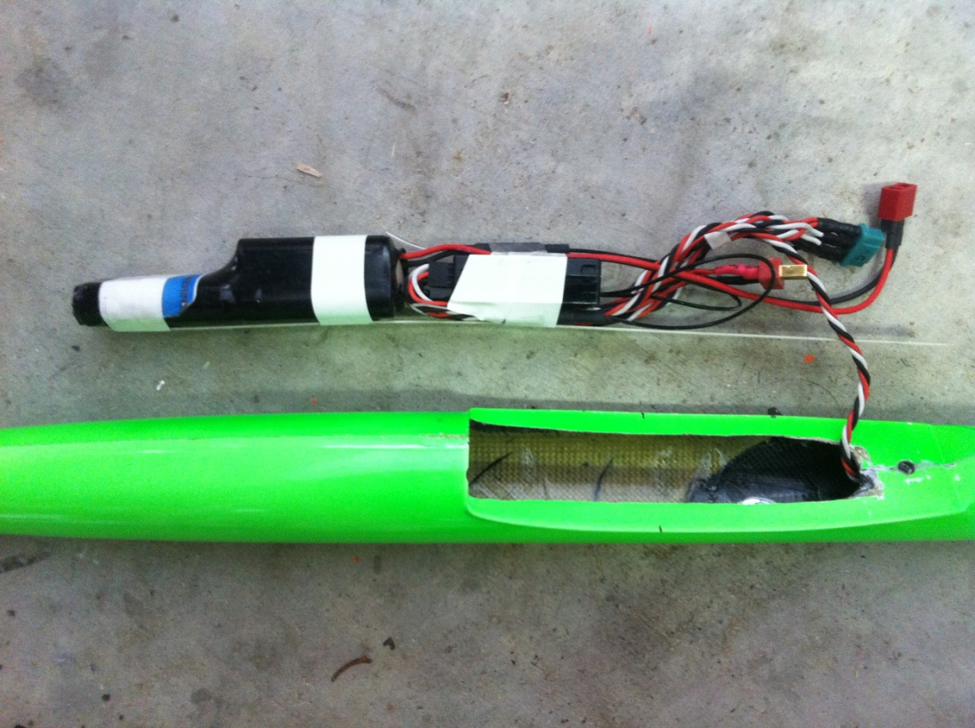

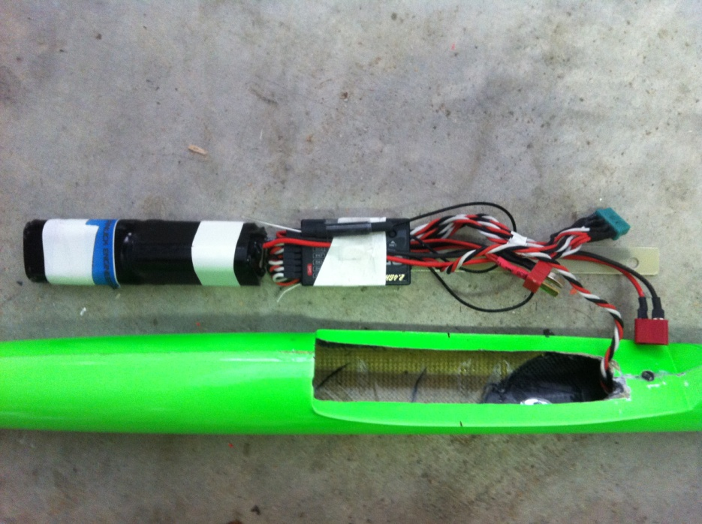

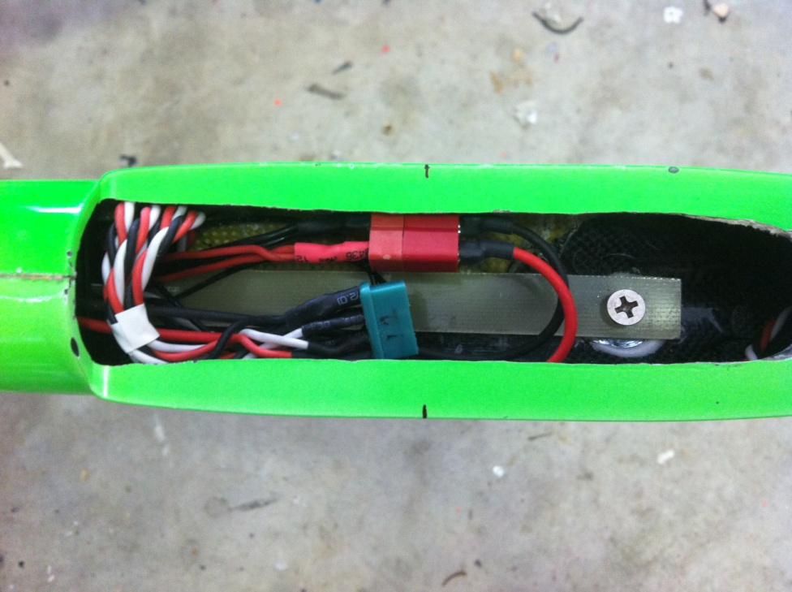

Transmitter Settings
I recommend setting up your transmitter to allow for camber during launch (approximately 2mm at root edge of flap). Especially when flying in light lift or with high wing loadings. Reflex is beneficial (1mm) for hands off flight but the benefit is small and might not be worth the effort. Snap flap is not particularly beneficial for typical flight conditions (unless using reflex) but you can use up to 1mm down at the flap root for maximum elevator deflection.

Setting maximum elevator deflection is a personal preference but I recommend avoiding throws large enough to stall the model. Begin with your model trimmed neutrally and flying into the wind with reasonable airspeed and lots of altitude. Smoothly apply full elevator. If your throws are too large, you will stall the model and must release the sticks letting the model dive until it regains airspeed and can be controlled again. If your elevator throw is small enough, the model will pull a tight loop and continue flying normally. You can increase the elevator throw until just before the point of stall. Depending on your CG, this typically ends up around 1.7mm measured at the tip of the elevator control surface versus the adjacent fixed trailing edge. This may seem like a small deflection but remember that the chord length of the elevator is so small (11mm) that even large angles of deflection result in small amounts of offset (for example, 1.7mm deflection = 9 degrees). See chart for other control surface throws and positions. All measurements are made between the trailing edge of the control surface and the adjacent fixed trailing edge (ie, flaps at root and ailerons at tips). I find that aileron to flap coupling is helpful for low speed handling but not necessary at higher speeds. For landing, I allow the ailerons to reflex approximately 1mm at full flap deployment (butterfly). With this set up, roughly 0.8mm of down elevator compensation is needed to maintain steady attitude thru full flap deployment. As a matter of personal preference, I like to use 25-30% exponential in slow speed modes to tame the throws around center but still have a larger throw in reserve if needed. For the smaller high speed throws, expo is not needed.

SLOW SPEEDS / LANDING FAST SPEEDS
 | UP | DOWN | UP | DOWN
Ailerons | 6mm | 4mm | 3.5mm | 2.5mm
Elevator | 3mm | 3mm | 1.7mm | 1.7mm
Flaps: 70-90 degree down for landing
** Note that 3mm of elevator throw must be used cautiously as it is enough to stall the model. I use it in landing mode only in case of bad turbulence in the landing area.

Ballast

Adding ballast is an effective way to increase the roll inertia of the model as well as to help it achieve the ideal lift coefficients without having to fly such tight circles. Permanent ballast should ideally be added to the wingtips by pouring lead shot and epoxy into the aileron servo opening and letting it run to the wingtip against the rear of the spar shearweb. This will provide the maximum roll stabilization and reduce bending loads on the wing spar. I prefer to add (5)ounces to each wingtip in this way. Temporary ballast may be added two ways: In the D-box of the wing ahead of the spar, or in the belly of the fuselage. I prefer to use the d-box as it adds less to the wing bending loads and has a theoretically stabilizing effect on the aeroelasticity of the wing (assuming you can ever make it flex!) The skin of the D-box is a very heavy layup and should be stiff enough to hold the lead shot dry (with no epoxy) without deforming. This allows you to fly the model with the d-box empty for lighter air of completely full of lead shot if the conditions are very strong. CG is maintained either by removing noseweight when the box is filled (roughly 6.5 oz) or by adding a stick of lead in the fuselage boom aft of the CG. To access the D-box ahead of the spar, a 6-7mm dia hole can be made at the root of the wing 15mm behind the wing leading edge. Inside you will find a spanwise tube leading to either side of the d-box. I have found that smaller #9 lead shot is the most easy to add and remove thru the small opening.
Adding ballast to the belly of the fuselage is the last option and with careful planning and routing of wires, it is possible to fit 10oz or more inside. Be sure to secure it strongly as it might slide in an impact and damage your radio gear and/or the airframe. The heaviest I have flown a K2mDP is 120oz and it flew fine in 40mph winds but benefitted from camber on launch.

Other Considerations

I recommend using loctite on the wing and stabilizer mounting screws and always do a pre / post flight check to make sure that they haven't loosened. In actuality, it is very seldom that I ever remove the stab from the fuselage. I have recently begun laying a thin string of 5min epoxy on the saddle before mounting it after the servo install is 100% completed. Smooth any excess with a gloved finger and clean up with alchohol.

Always take the utmost care when building and flying your Kinetic. Attention to detail will result in the safest, most capable, and most enjoyable plane. Remember to maintain your plane and always give a thorough check before and after each flight. Dynamic soaring is dangerous. Always position yourself behind a suitable bunker and advise all present to do the same when you are flying as all DS planes will fail at some point and no one knows exactly when that will be. Have fun and go fast and be careful ;o)!!!!!

Don't hesitate to call or email me with any questions.

Thanks,
Spencer Lisenby
www.DSKinetic.com
spencer@dskineitc.com
310-697-9624cell
Skype: sll914

